

**Computer and Laptop Accessories Management System**

**Submitted By:**

**Asad Mehmood , 2020-CS-10**

**Submitted To:**

**Ms. Maida Shahid**

**For Fulfillment of Mid Term Project**

**CS 162 Object Oriented Programming**

**Department of Computer Science**

**University of Engineering and Technology, Lahore**

**Abstract:**

In this program, there will be three users.

1. Admin.
2. Employee.
3. Customer.

* Admin can add employees, delete employee, view the employees and view the available stock.
* Employee can add items category wise. There are two categories: “Computer” and “Laptop”. Employee can view all the added products, change the prices of products, sort the products in descending order and change the password of their account.
* Customer can view the available stock, place the order and pay the bill.

**Functional Requirement:**

There are three type of users:

1. Admin.
2. Employee
3. Customer

**For Admin:**

1. As a admin, I can add employees.
2. As a admin, I can view employees.
3. As a admin. I can delete employees.
4. As a admin, I can view the available stock.

**For Employee:**

1. As a employee, I can add items category wise.
2. As a employee, I can view items category wise.
3. As a employee, I can change price of entered products.
4. As a employee, I can sort the products in descending order.
5. As a employee, I can change the password of account.

**For Customer:**

1. As a customer, I can view the available stock.
2. As a customer, I can place my order.
3. As a customer, I can pay the bill.

**Wireframes:**

**Admin:**

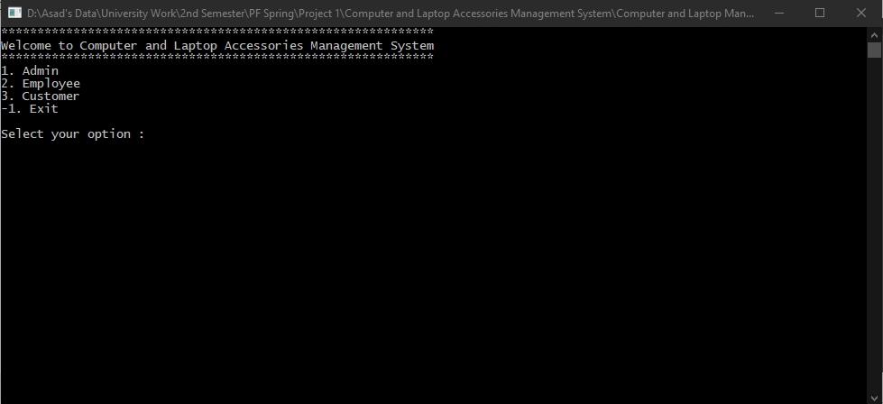

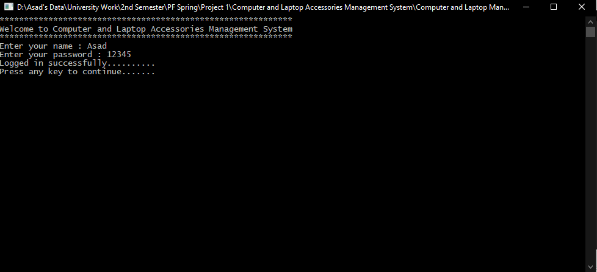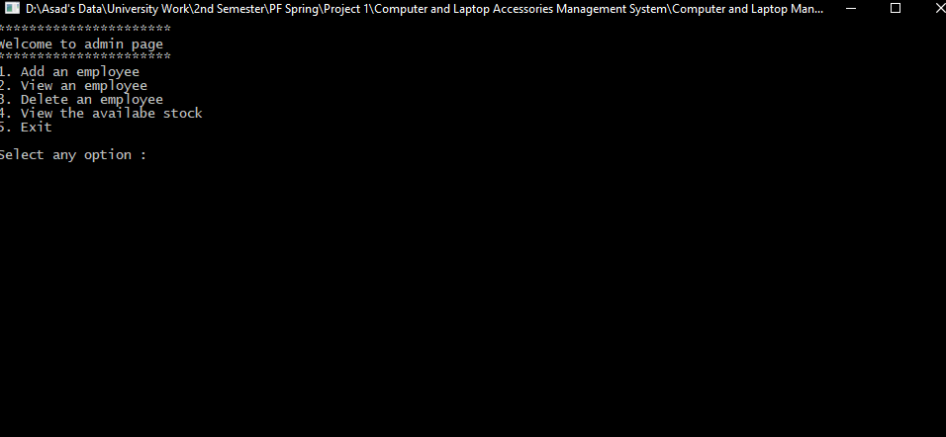

**Employee:**

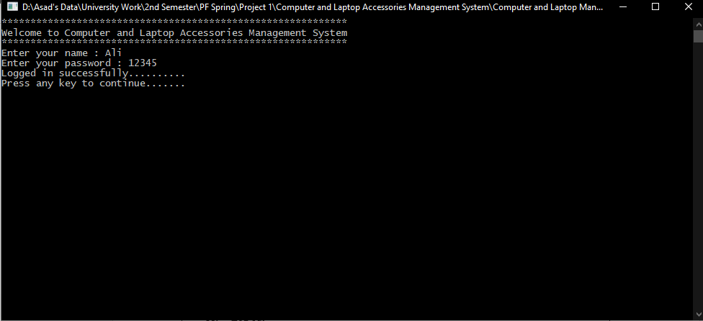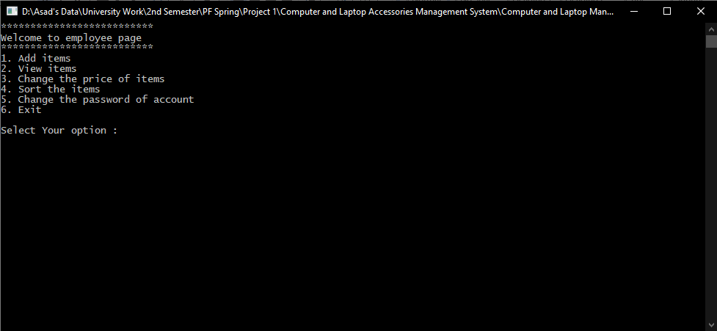

**Customer:**

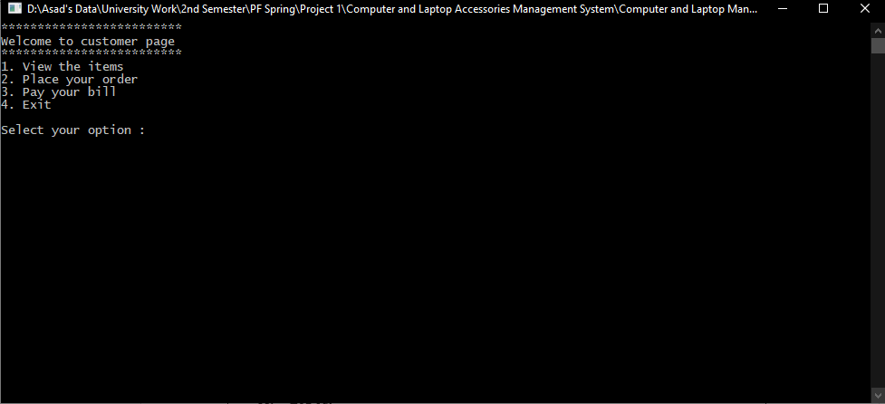

**Data Structure:**

Globally declared variables and arrays:

**Variables:**

int i=0;

int q=0;

int r=0;

int t=0;

int a=0;

int s=0;

int id3=0;

int id5=0;

string select;

string computer_order_item;

string laptop_order_item;

int computer_order_quantity;

int laptop_order_quantity;

**Arrays:**

string employee_name[10];

string employee_pass[10];

string employee_cnic[10];

string computer_items[10];

int computer_price[10];

int computer_quantity[10];

string laptop_items[10];

int laptop_price[10];

int laptop_quantity[10];

string computerorder[10];

int computerquantity[10];

string laptoporder[10];

int laptopquantity[10];

**Functions:**

void main_menu();

void admin(int option);

void admin_welcome();

void add_employee();

void view_employee();

void delete_employee();

void view_stock();

void employee(int option);

void employee_welcome();

void add_items();

void view_items();

void price_change();

void sorting();

void password_change();

void customer(int option);

void customer_welcome();

void place_the_order(string select);

void pay_the_bill();

**Function Header and Description:**

void main_menu();

This Function will display the main menu.

void admin(int option);

This Function will call entire admin port

void admin_welcome();

This function will display admin welcome.

void add_employee();

This Function will be used to add employees.

void view_employee();

This function will be used to view all the added employees.

void delete_employee();

This function will be used to deleted employee.

void view_stock();

This function will display all the products added.

void employee(int option);

This function will call entire employee portion.

void employee_welcome();

This function will display employee welcome.

void add_items();

This function will used to add products category wise.

void view_items();

This function will used to view products category wise.

void price_change();

This function will used to change the price of products.

void sorting();

This function will sort all the products in descending order.

void password_change();

This function will used to change the password of login account.

void customer(int option);

This function will be used to call entire customer portion.

void customer_welcome();

This function will be used to display customer welcome.

void place_the_order(string select);

This function will be used to place order by customer.

void pay_the_bill();

This function will be used to pay the bill by customer.

**Flow Chart of all functions:**

Add_employee();

View_stock();

Delete_employee();

View_employee();

Sorting();

Change_the_password();

Change_the_price()

View_items();

Add_items();

Pay_the_bill();

Place_the_order();

View_stock();

**Code:**

using System;

using System.IO;

namespace Computer_And_Laptop_Accessories_Management_System

{

class Program

{

// Arrays

static string [] employee_name = new string[10];

static string [] employee_cnic = new string[10];

static string [] employee_pass = new string[10];

static string [] employee_name2 = new string[10];

static string [] employee_cnic2 = new string[10];

static string [] employee_pass2 = new string[10];

static string [] computer_items = new string[10];

static int [] computer_price = new int[10];

static int [] computer_quantity = new int[10];

static string [] computer_items2 = new string[10];

static int [] computer_price2 = new int[10];

static int [] computer_quantity2 = new int[10];

static string [] laptop_items = new string[10];

static int [] laptop_price = new int[10];

static int [] laptop_quantity = new int[10];

static string [] laptop_items2 = new string[10];

static int [] laptop_price2 = new int[10];

static int [] laptop_quantity2 = new int [10];

static string [] computerorder = new string[10];

static int [] computerquantity = new int[10];

static string [] laptoporder = new string[10];

static int [] laptopquantity = new int[10];

// Counters and variables

static int i=0;

static int q=0;

static int r=0;

static int t=0;

static int a=0;

static int s=0;

static int id3=0;

static int id5=0;

static int s1=0;

static int idx_1=0;

static int s2=0;

static int idx_2=0;

static int s_3=0;

static int idx_3=0;

static int s_2=0;

static int a_2=0;

static string file = "D://Asad's Data/University Work/Object Oriented Programming ( Summer )/Week 1/Project/Computer And Laptop Accessories Management System/admin.txt";

static string file2 = "D://Asad's Data/University Work/Object Oriented Programming ( Summer )/Week 1/Project/Computer And Laptop Accessories Management System/items.txt";

static string file3 = "D://Asad's Data/University Work/Object Oriented Programming ( Summer )/Week 1/Project/Computer And Laptop Accessories Management System/items2.txt";

static string select;

static string computer_order_item;

static string laptop_order_item;

static int computer_order_quantity;

static int laptop_order_quantity;

static string write_emp_name;

static string write_emp_cnic;

static string write_emp_pass;

static void main_menu()

{

Console.WriteLine("************************************************************");

Console.WriteLine("Welcome to Computer and Laptop Accessories Management System");

Console.WriteLine("************************************************************");

}

static void admin_welcome()

{

Console.WriteLine("**********************");

Console.WriteLine("Welcome to admin page ");

Console.WriteLine("**********************");

}

static void admin(int option)

{

Console.Clear();

string user = "Asad"; // admin fixed username

string pass = "12345"; // admin fixed password

string userName;

string userPass;

main_menu();

Console.WriteLine("Enter your name : ");

userName = Console.ReadLine();

Console.WriteLine("Enter your password : ");

userPass = Console.ReadLine();

if(userName==user && userPass==pass)

{ // this will check admin name and pass is correct or not

Console.WriteLine("Logged in successfully..........");

Console.WriteLine("Press any key to continue....... ");

Console.ReadLine();

Console.Clear();

admin_welcome();

while(option!=5)

{

Console.WriteLine("1. Add an employee ");

Console.WriteLine("2. View an employee ");

Console.WriteLine("3. Delete an employee ");

Console.WriteLine("4. View the availabe stock ");

Console.WriteLine("5. Exit ");

Console.WriteLine("Select any option : ");

option = int.Parse(Console.ReadLine());

if(option==1)

{

add_employee(); // this will call add employee function

read_employee();

}

if(option==2)

{

view_employee(); // this will call view employee function

Console.ReadLine();

Console.Clear();

admin_welcome();

}

if(option==3)

{

delete_employee(); // this will call delete the employee function

Console.ReadLine();

Console.Clear();

admin_welcome();

}

if(option==4)

{

view_stock(); // this will call view stock function

Console.ReadLine();

Console.Clear();

admin_welcome();

}

if(option==5){

Console.Clear();

main_menu();

}

}

}

else

{

Console.WriteLine("Invalid uername or password.......");

Console.WriteLine("Try again .....");

Console.ReadLine();

Console.Clear();

main_menu();

}

}

static void add_employee()

{

Console.Clear();

string agree;

admin_welcome();

Console.WriteLine("There are some rules for the job. ");

Console.WriteLine("1. You have to come on time which is 9'o clock. ");

Console.WriteLine("2. Your job time will be 8 hours. ");

Console.WriteLine("3. You will get salary on 5 of every month and your salary will be fixed which is 15000. ");

Console.WriteLine("Are you agree to all the terms and conditions : ");

agree = Console.ReadLine();

if(agree=="Yes")

{

Console.WriteLine("Enter your name : ");

employee_name[i] = Console.ReadLine();

write_emp_name = employee_name[i];

Console.WriteLine("Enter your CNIC number : ");

employee_cnic[i] = Console.ReadLine();

write_emp_cnic = employee_cnic[i];

Console.WriteLine("Enter your password : ");

employee_pass[i] = Console.ReadLine();

write_emp_pass = employee_pass[i];

Console.WriteLine("Congratulations!!!You are hired....... "); // employee will be added one by one

Console.ReadLine();

File.WriteAllText(file,write_emp_name + "," + write_emp_cnic + "," + write_emp_pass);

q=i; // this counter will take index value

i++;

Console.Clear();

admin_welcome();

}

if(agree=="No")

{

Console.WriteLine("Hope for your better future.Have a nice day ");

Console.ReadLine();

Console.Clear();

admin_welcome();

}

}

static void read_employee()

{

string record = File.ReadAllText(file);

employee_name2[idx_1] = (getrecord(record, 0));

employee_cnic2[idx_1] = (getrecord(record, 1));

employee_pass2[idx_1] = (getrecord(record, 2));

s1=idx_1;

idx_1++;

}

static void view_employee()

{

Console.Clear();

admin_welcome();

Console.WriteLine("Employee Name"+"\t"+"CNIC Number"+"\t"+"Password");

for(int k1=0;k1<=q;k1++)

{

Console.WriteLine(employee_name2[k1]+"\t"+employee_cnic2[k1]+"\t"+employee_pass2[k1]);

}

}

static void delete_employee()

{

Console.Clear();

string name,cnic,password;

bool isFound = false;

admin_welcome();

Console.WriteLine("Enter your name : ");

name = Console.ReadLine();

Console.WriteLine("Enter your CNIC number : ");

cnic = Console.ReadLine();

Console.WriteLine("Enter your password : ");

password = Console.ReadLine();

for(int w=0;w<=q;w++)

{

if(name==employee_name2[w] && cnic==employee_cnic2[w] && password==employee_pass2[w])

{

employee_name2[w]=" ";

employee_cnic2[w]=" ";

employee_pass2[w]=" ";

isFound = true;

}

}

if(isFound == true)

{

Console.WriteLine("User deleted successfully ......");

}

else if(isFound == false)

{

Console.WriteLine("User is not available.....");

}

}

static void view_stock(){

Console.Clear();

admin_welcome();

Console.WriteLine("Enter the category : ");

select = Console.ReadLine();

if(select=="Computer")

{

Console.WriteLine("Item Name "+"\t"+"Price "+"\t"+"Quantity");

for(int y=0;y<=t;y++){

Console.WriteLine(computer_items2[y]+"\t"+computer_price2[y]+"\t"+computer_quantity2[y]);

}

}

if(select=="Laptop"){

Console.WriteLine("Item Name "+"\t"+"Price "+"\t"+"Quantity");

for(int y2=0;y2<=s_2;y2++){

Console.WriteLine(laptop_items2[y2]+"\t"+laptop_price2[y2]+"\t"+laptop_quantity2[y2]);

}

}

}

static string getrecord(string record, int x_1)

{

int commas = x_1;

int commasfound = 0;

string store_1 = "";

int f_1 = 0;

while (commasfound < 3 && f_1 < record.Length)

{

char c_1 = record[f_1];

if (c_1 == ',')

{

commasfound = commasfound + 1;

}

else if (commasfound == x_1)

{

store_1 = store_1 + c_1;

}

f_1 = f_1 + 1;

}

return store_1;

}

static void employee_welcome()

{

Console.WriteLine("**************************");

Console.WriteLine("Welcome to employee page ");

Console.WriteLine("**************************");

}

static void employee(int option)

{

Console.Clear();

string emp_Name;

string emp_Pass;

main_menu();

Console.WriteLine("Enter your name : ");

emp_Name = Console.ReadLine();

Console.WriteLine("Enter your password : ");

emp_Pass = Console.ReadLine();

for(int e=0;e<=q;e++)

{

if(emp_Name==employee_name2[e] && emp_Pass==employee_pass2[e]){ // this will check employee username and password and then log in

Console.WriteLine("Logged in successfully..........");

Console.WriteLine("Press any key to continue....... ");

Console.ReadLine();

Console.Clear();

employee_welcome();

while(option!=6){

Console.WriteLine("1. Add items ");

Console.WriteLine("2. View items ");

Console.WriteLine("3. Change the price of items ");

Console.WriteLine("4. Sort the items ");

Console.WriteLine("5. Change the password of account ");

Console.WriteLine("6. Exit ");

Console.WriteLine("Select Your option : ");

option = int.Parse(Console.ReadLine());

if(option==1){

add_items();

Console.ReadLine();

Console.Clear();

employee_welcome(); // this will call add items function

}

if(option==2){

view_items(); // this will call view items function

Console.ReadLine();

Console.Clear();

employee_welcome();

}

if(option==3){

price_change(); // this will call price change function

}

if(option==4){

sorting(); // this will call sorting of items function

Console.ReadLine();

Console.Clear();

employee_welcome();

}

if(option==5){

password_change(); // this will call password change function

}

if(option==6){

Console.Clear();

main_menu();

}

}

}

else if(emp_Name!=employee_name2[e] && emp_Pass!=employee_pass2[e]){

Console.WriteLine("Invalid username or password.......");

Console.ReadLine();

Console.Clear();

main_menu();

}

}

}

static void add_items(){

Console.Clear();

employee_welcome();

string category;

Console.WriteLine("Enter the category : ");

category = Console.ReadLine();

if(category=="Computer")

{

add_computer();

read_items();

}

if(category=="Laptop")

{

add_laptop();

read_items2();

}

}

static void add_computer(){

string computeritem1;

int computerprice1,computerquantity1;

string write_com_items;

int write_com_price;

int write_com_quan;

Console.WriteLine("Enter the item : ");

computeritem1 = Console.ReadLine();

Console.WriteLine("Enter the price of item : ");

computerprice1 = int.Parse(Console.ReadLine());

Console.WriteLine("Enter the quantity : ");

computerquantity1 = int.Parse(Console.ReadLine());

if(computerprice1>0 && computerquantity1>0){

computer_items[r]=computeritem1;

write_com_items = computer_items[r];

computer_price[r]=computerprice1;

write_com_price = computer_price[r];

computer_quantity[r]=computerquantity1;

write_com_quan = computer_quantity[r];

File.WriteAllText(file2,write_com_items + "," + write_com_price + "," + write_com_quan);

t=r; // this will store index value

r++;

Console.WriteLine("Item added successfully ....."); // items will be added one by one

}

else if(computerprice1<0 || computerquantity1<0)

{

Console.WriteLine("You enter invalid value.....");

}

}

static void add_laptop(){

string laptopitem_1;

int laptopprice_1,laptopquantity_1;

string write_lap_items;

int write_lap_price;

int write_lap_quan;

Console.WriteLine("Enter the item : ");

laptopitem_1 = Console.ReadLine();

Console.WriteLine("Enter the price of item : ");

laptopprice_1 = int.Parse(Console.ReadLine());

Console.WriteLine("Enter the quantity : ");

laptopquantity_1 = int.Parse(Console.ReadLine());

if(laptopprice_1>0 && laptopquantity_1>0)

{

laptop_items[a_2]=laptopitem_1;

write_lap_items = laptop_items[a_2];

laptop_price[a_2]=laptopprice_1;

write_lap_price = laptop_price[a_2];

laptop_quantity[a_2]=laptopquantity_1;

write_lap_quan = laptop_quantity[a_2];

File.WriteAllText(file3,write_lap_items + "," + write_lap_price + "," + write_lap_quan);

s_2=a_2; // this will store index value

a_2++;

Console.WriteLine("Item added successfully ....."); // items will be added one by one

}

else if(laptopprice_1<0 || laptopquantity_1<0)

{

Console.WriteLine("You enter invalid value.....");

}

}

static void read_items()

{

string record_2 = File.ReadAllText(file2);

computer_items2[idx_2] = (getrecord(record_2, 0));

computer_price2[idx_2] = int.Parse((getrecord(record_2, 1)));

computer_quantity2[idx_2] = int.Parse((getrecord(record_2, 2)));

s2=idx_2;

idx_2++;

}

static void read_items2()

{

string record_3 = File.ReadAllText(file3);

laptop_items2[idx_3] = (getrecord(record_3, 0));

laptop_price2[idx_3] = int.Parse(getrecord(record_3, 1));

laptop_quantity2[idx_3] = int.Parse(getrecord(record_3, 2));

s_3=idx_3;

idx_3++;

}

static void view_items(){

Console.Clear();

employee_welcome();

Console.WriteLine("Enter the category : ");

select = Console.ReadLine();

if(select=="Computer")

{

Console.WriteLine("Item Name "+"\t"+"Price "+"\t"+"Quantity");

for(int y_01=0;y_01<=t;y_01++)

{

Console.WriteLine(computer_items2[y_01]+"\t"+computer_price2[y_01]+"\t"+computer_quantity2[y_01]);

}

}

if(select=="Laptop")

{

Console.WriteLine("Item Name "+"\t"+"Price "+"\t"+"Quantity");

for(int y_2=0;y_2<=s_2;y_2++)

{

Console.WriteLine(laptop_items2[y_2]+"\t"+laptop_price2[y_2]+"\t"+laptop_quantity2[y_2]);

}

}

}

string getrecord_3(string record_3, int x_3)

{

int commas_3 = x_3;

int commasfound_3 = 0;

string store_3 = "";

int f_3 = 0;

while (commasfound_3 < 3 && f_3 < record_3.Length)

{

char c_3 = record_3[f_3];

if (c_3 == ',')

{

commasfound_3 = commasfound_3 + 1;

}

else if (commasfound_3 == x_3)

{

store_3 = store_3 + c_3;

}

f_3 = f_3 + 1;

}

return store_3;

}

string getrecord_2(string record_2, int x_2)

{

int commas_2 = x_2;

int commasfound_2 = 0;

string store_2 = "";

int f_2 = 0;

while (commasfound_2 < 3 && f_2 < record_2.Length)

{

char c_2 = record_2[f_2];

if (c_2 == ',')

{

commasfound_2 = commasfound_2 + 1;

}

else if (commasfound_2 == x_2)

{

store_2 = store_2 + c_2;

}

f_2 = f_2 + 1;

}

return store_2;

}

static void price_change(){

Console.Clear();

employee_welcome();

int newprice;

int old_price;

string item_name;

Console.WriteLine("Enter the category : ");

select = Console.ReadLine();

if(select=="Computer")

{

Console.WriteLine("Enter name of item : ");

item_name = Console.ReadLine();

Console.WriteLine("Enter price of old price of item : ");

old_price = int.Parse(Console.ReadLine());

for(int u=0;u<=t;u++)

{

if(item_name==computer_items2[u] && old_price==computer_price2[u])

{ // this will check entered name and price is same as added

Console.WriteLine("Enter the new price of item : ");

newprice = int.Parse(Console.ReadLine());

Console.WriteLine("Price of item is changed successfully....");

Console.ReadLine();

computer_price2[u]=newprice;

Console.ReadLine();

Console.Clear();

}

}

}

if(select=="Laptop")

{

Console.WriteLine("Enter name of item : ");

item_name = Console.ReadLine();

Console.WriteLine("Enter price of old price of item : ");

old_price = int.Parse(Console.ReadLine());

for(int o=0;o<=s_2;o++)

{

if(item_name==laptop_items2[o] && old_price==laptop_price2[o])

{

Console.WriteLine("Enter the new price of item : ");

newprice = int.Parse(Console.ReadLine());

Console.WriteLine("Price of item is changed successfully....");

Console.ReadLine();

laptop_price2[o]=newprice;

Console.ReadLine();

Console.Clear();

}

}

}

}

static void sorting(){

Console.Clear();

employee_welcome();

int [] newarray = new int [10];

for(int f=0;f<=t;f++){

newarray[f]=computer_price2[f];

}

int largesti=0;

int largest=0;

int [] copyarray = new int [10];

largest=newarray[0];

for(int v=0;v<=t;v++)

{

for(int x=1; x<=t; x++)

{

if(largest<newarray[x])

{

largest=newarray[x];

largesti=x;

}

}

copyarray[v]=largesti;

newarray[largesti]=-1;

largest=newarray[0];

largesti=0;

}

int []newarray2 = new int[10];

for(int f2=0;f2<=s_2;f2++)

{

newarray2[f2]=laptop_price2[f2];

}

int largesti2=0;

int largest2=0;

int [] copyarray2 = new int[10];

largest2=newarray2[0];

for(int v2=0;v2<=s_2;v2++)

{

for(int x2=1; x2<=s_2; x2++)

{

if(largest2<newarray2[x2])

{

largest2=newarray2[x2];

largesti2=x2;

}

}

copyarray2[v2]=largesti2;

newarray2[largesti2]=-1;

largest2=newarray2[0];

largesti2=0;

}

Console.WriteLine(" Following are the computer items ");

Console.WriteLine("Item Name "+"\t"+"Price "+"\t"+"Quantity");

for(int m=0;m<=t;m++)

{

int id=copyarray[m];

Console.WriteLine(computer_items2[id]+"\t"+computer_price2[id]+"\t"+computer_quantity2[id]);

}

Console.WriteLine(" Following are the laptop items ");

Console.WriteLine("Item Name "+"\t"+"Price "+"\t"+"Quantity");

for(int m2=0;m2<=s_2;m2++)

{

int id2=copyarray2[m2];

Console.WriteLine(laptop_items2[id2]+"\t"+laptop_price2[id2]+"\t"+laptop_quantity2[id2]);

}

}

static void password_change(){

Console.Clear();

employee_welcome();

string check_pass;

string new_pass;

Console.WriteLine("Enter your previous password : ");

check_pass = Console.ReadLine();

for(int id1=0;id1<=q;id1++)

{

if(check_pass==employee_pass2[id1])

{

Console.WriteLine("Enter your new password : ");

new_pass = Console.ReadLine();

employee_pass2[id1]=new_pass;

Console.WriteLine("Your password is changed successfully.....");

Console.ReadLine();

Console.Clear();

employee_welcome();

}

else if(check_pass!=employee_pass2[id1]){

Console.WriteLine("Wrong password ......");

Console.ReadLine();

Console.Clear();

employee_welcome();

}

}

}

static void customer_welcome()

{

Console.WriteLine("*************************");

Console.WriteLine("Welcome to customer page ");

Console.WriteLine("*************************");

}

static void customer(int option)

{

Console.Clear();

customer_welcome();

while(option!=4){

Console.WriteLine("1. View the items ");

Console.WriteLine("2. Place your order ");

Console.WriteLine("3. Pay your bill ");

Console.WriteLine("4. Exit ");

Console.WriteLine("Select your option : ");

option = int.Parse(Console.ReadLine());

if(option==1){

view_stock(); // this will call view stock function

Console.ReadLine();

Console.Clear();

customer_welcome();

}

if(option==2){

place_the_order(select); // this will call place the order function

}

if(option==3){

pay_the_bill(); // this will call pay the bill function

Console.ReadLine();

Console.Clear();

customer_welcome();

}

if(option==4){

Console.Clear();

customer_welcome();

}

}

}

static void place_the_order(string select){

Console.Clear();

customer_welcome();

Console.WriteLine("Select your category : ");

select = Console.ReadLine();

if(select=="Computer")

{

Console.WriteLine("Enter Your Item : ");

computer_order_item = Console.ReadLine();

Console.WriteLine("Enter The Quantity : ");

computer_order_quantity = int.Parse(Console.ReadLine());

for(int idx1=0;idx1<=t;idx1++)

{

if(computer_order_item==computer_items[idx1])

{

if(computer_quantity2[idx1]==0 || computer_quantity2[idx1]<computer_order_quantity)

{

Console.WriteLine("Sorry product is not available......");

}

else if(computer_order_quantity<=computer_quantity2[idx1])

{

Console.WriteLine("Your order is added successfully......");

computerorder[idx1]=computer_order_item;

computerquantity[idx1]=computer_order_quantity;

computer_quantity2[idx1]= computer_quantity2[idx1]-computer_order_quantity;

id3++;

}

}

}

}

if(select=="Laptop")

{

Console.WriteLine("Enter Your Item : ");

laptop_order_item = Console.ReadLine();

Console.WriteLine("Enter The Quantity : ");

laptop_order_quantity = int.Parse(Console.ReadLine());

for(int idx2=0;idx2<=s_2;idx2++)

{

if(laptop_order_item==laptop_items2[idx2])

{

if(laptop_quantity2[idx2]==0 || laptop_quantity2[idx2]<laptop_order_quantity){

Console.WriteLine("Sorry product is not available......");

}

else if(laptop_order_quantity<=laptop_quantity2[idx2])

{

Console.WriteLine("Your order is added successfully......");

laptoporder[idx2]=laptop_order_item;

laptopquantity[idx2]=laptop_order_quantity;

laptop_quantity2[idx2]= laptop_quantity2[idx2]-laptop_order_quantity;

id5++;

}

}

}

}

Console.ReadLine();

Console.Clear();

customer_welcome();

}

static void pay_the_bill(){

Console.Clear();

customer_welcome();

int [] price1 = new int[10];

int [] price2 = new int[10];

int bill1=0,bill2=0,total=0;

for(int as1=0;as1<id3;as1++)

{

for(int as2=0;as2<=t;as2++)

{

if(computerorder[as1]==computer_items2[as2])

{

price1[as1]=computer_price2[as2]*computerquantity[as1];

}

}

}

for(int b1=0;b1<id3;b1++)

{

bill1+=price1[b1];

}

for(int as3=0;as3<id5;as3++)

{

for(int as4=0;as4<=s;as4++)

{

if(laptoporder[as3]==laptop_items2[as4]) {

price2[as3]=laptop_price2[as4]*laptopquantity[as3];

}

}

}

for(int b2=0;b2<id5;b2++)

{

bill2+=price2[b2];

}

Console.WriteLine("Following is the bill for computer items ");

Console.WriteLine("Name Of Items"+"\t"+"Quantity"+"\t"+"Price");

for(int id4=0;id4<id3;id4++)

{

Console.WriteLine(computerorder[id4]+"\t"+computerquantity[id4]+"\t"+price1[id4]);

}

Console.WriteLine("Your computer product bill is : "+bill1);

Console.WriteLine("Following is the bill for laptop items ");

Console.WriteLine("Name Of Items"+"\t"+"Quantity"+"\t"+"Price");

for(int id6=0;id6<id5;id6++)

{

Console.WriteLine(laptoporder[id6]+"\t"+laptopquantity[id6]+"\t"+price2[id6]);

}

Console.WriteLine("Your laptop product bill is : "+bill2);

total=bill1+bill2;

Console.WriteLine("Your total bill will be : "+total);

Console.WriteLine("Thanks For Your Payment....");

}

static void Main(string[] args)

{

main_menu();

int option=0;

while(option!=-1){

Console.WriteLine("1. Admin ");

Console.WriteLine("2. Employee ");

Console.WriteLine("3. Customer ");

Console.WriteLine("-1. Exit ");

Console.WriteLine("Select your option : ");

option = int.Parse(Console.ReadLine());

if(option==1){

admin(option); // this will call the admin function

}

if(option==2){

employee(option); // this will call employee function

}

if(option==3){

customer(option); // this will call customer function

}

}

}

}

}